15/12/2023

Chakradhar Bhogapurapu

SETS

Set type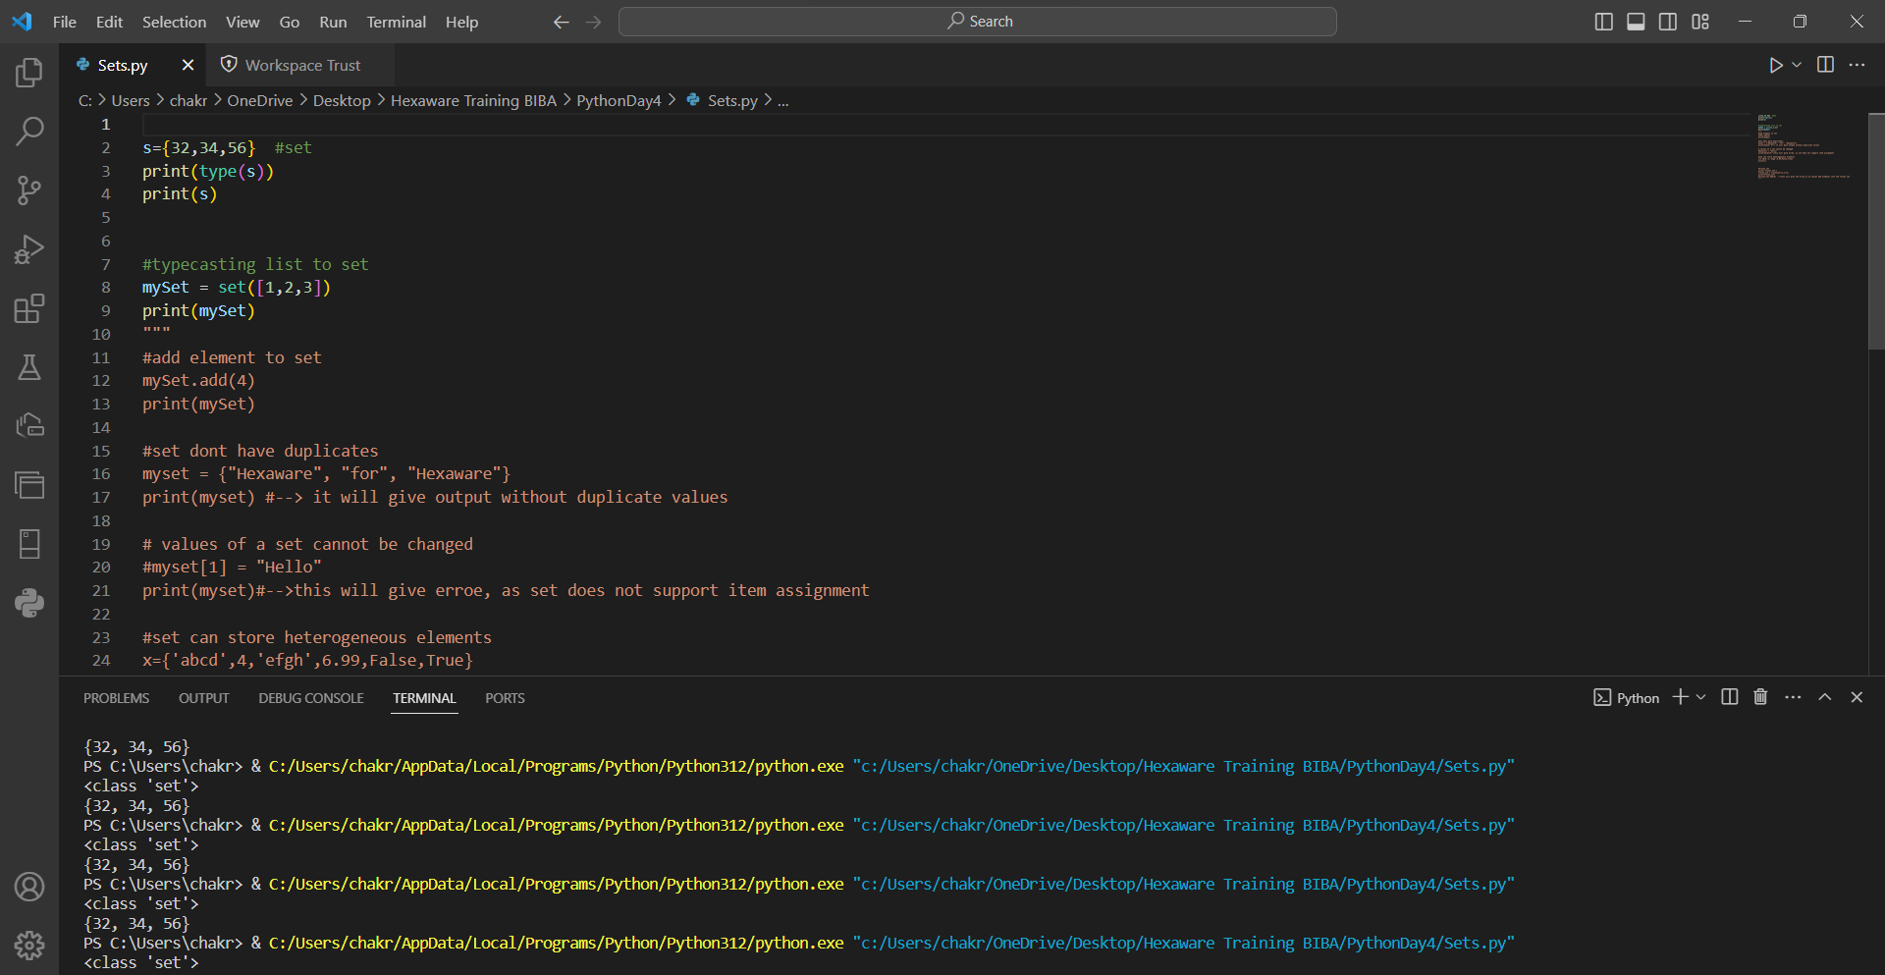

add()

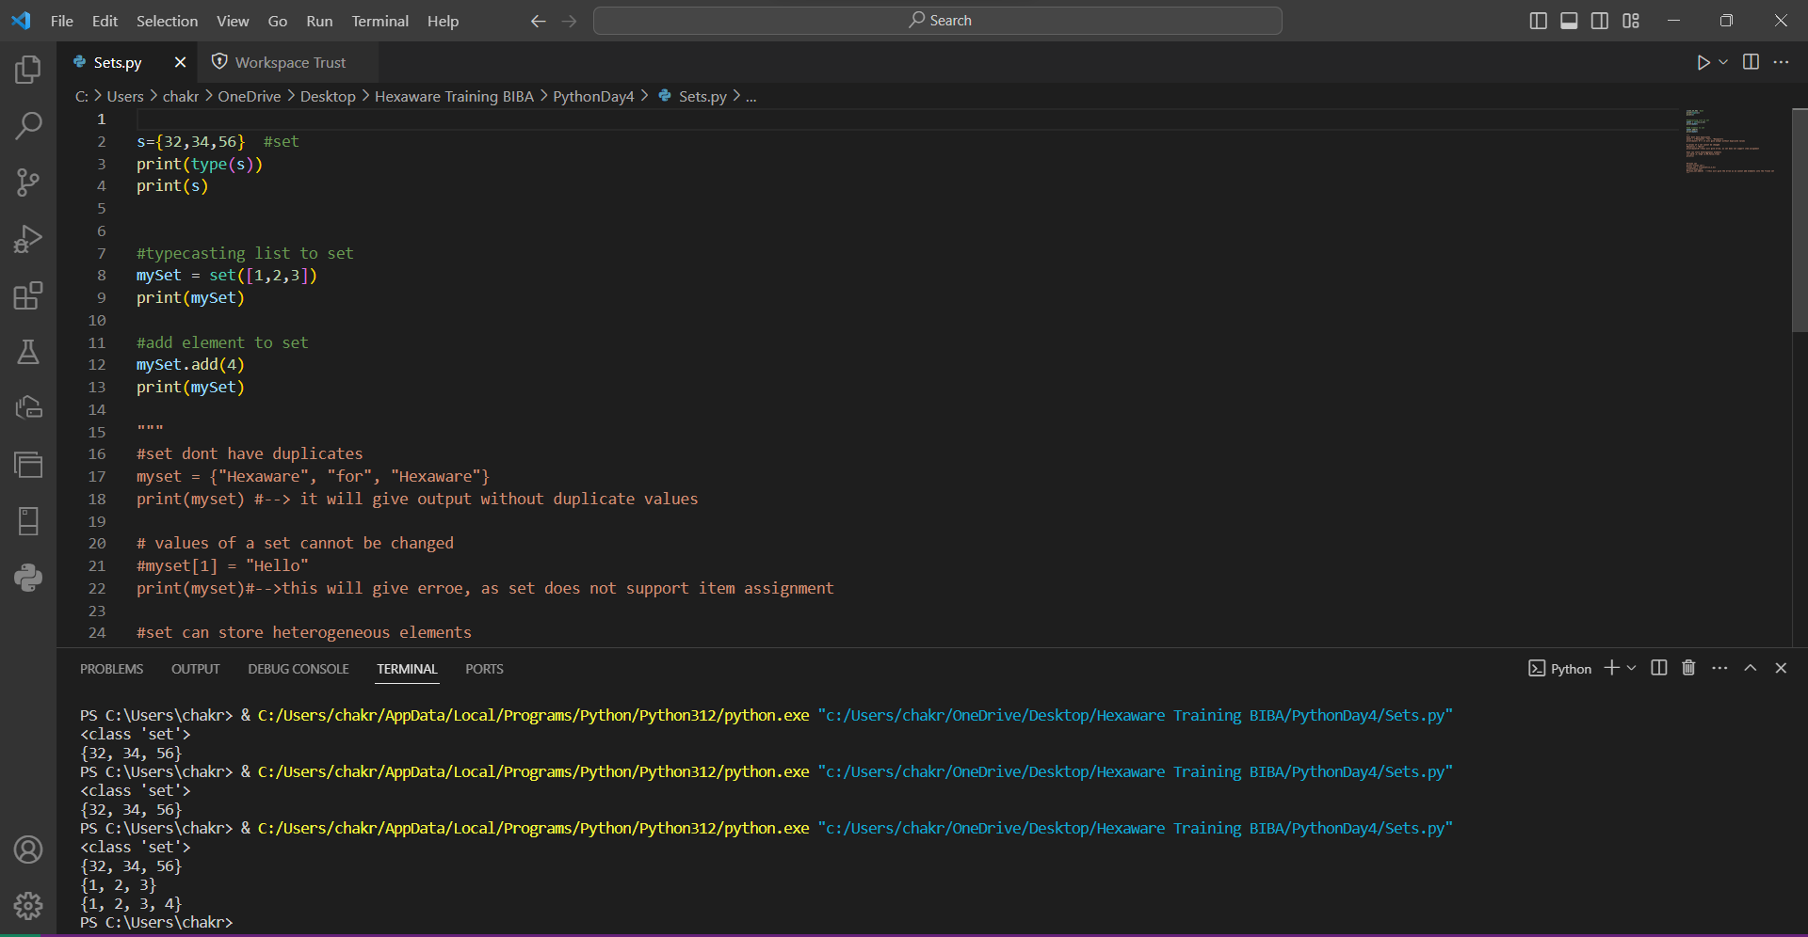

Duplicate : set do not allow duplicates

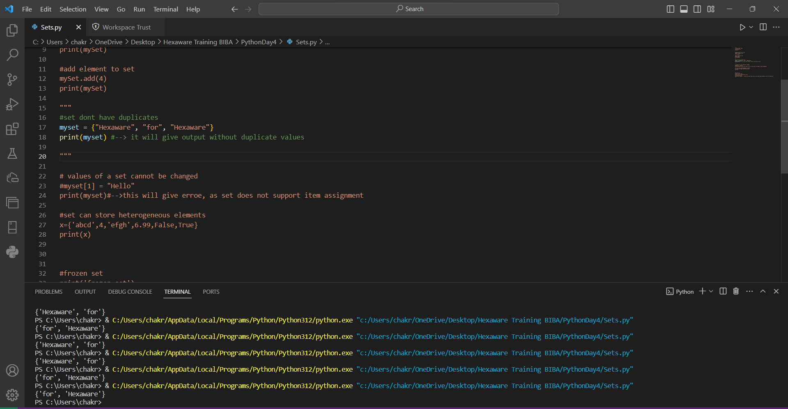

No value can be assigned to a particular index in sets

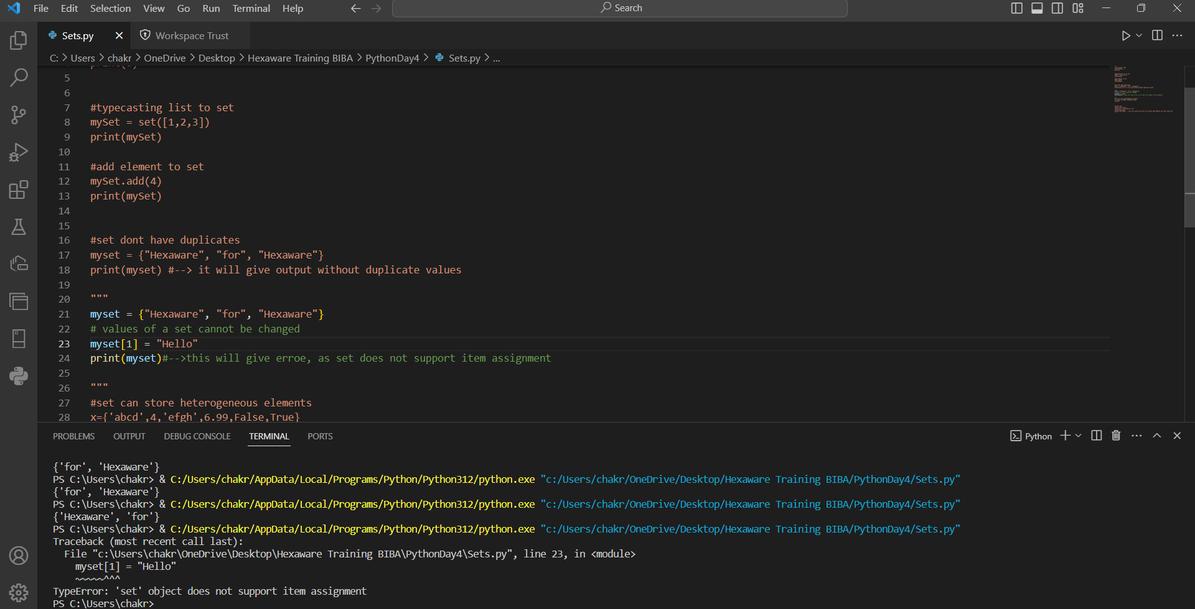

Heterpgeneous : Different data type elements can be there in set

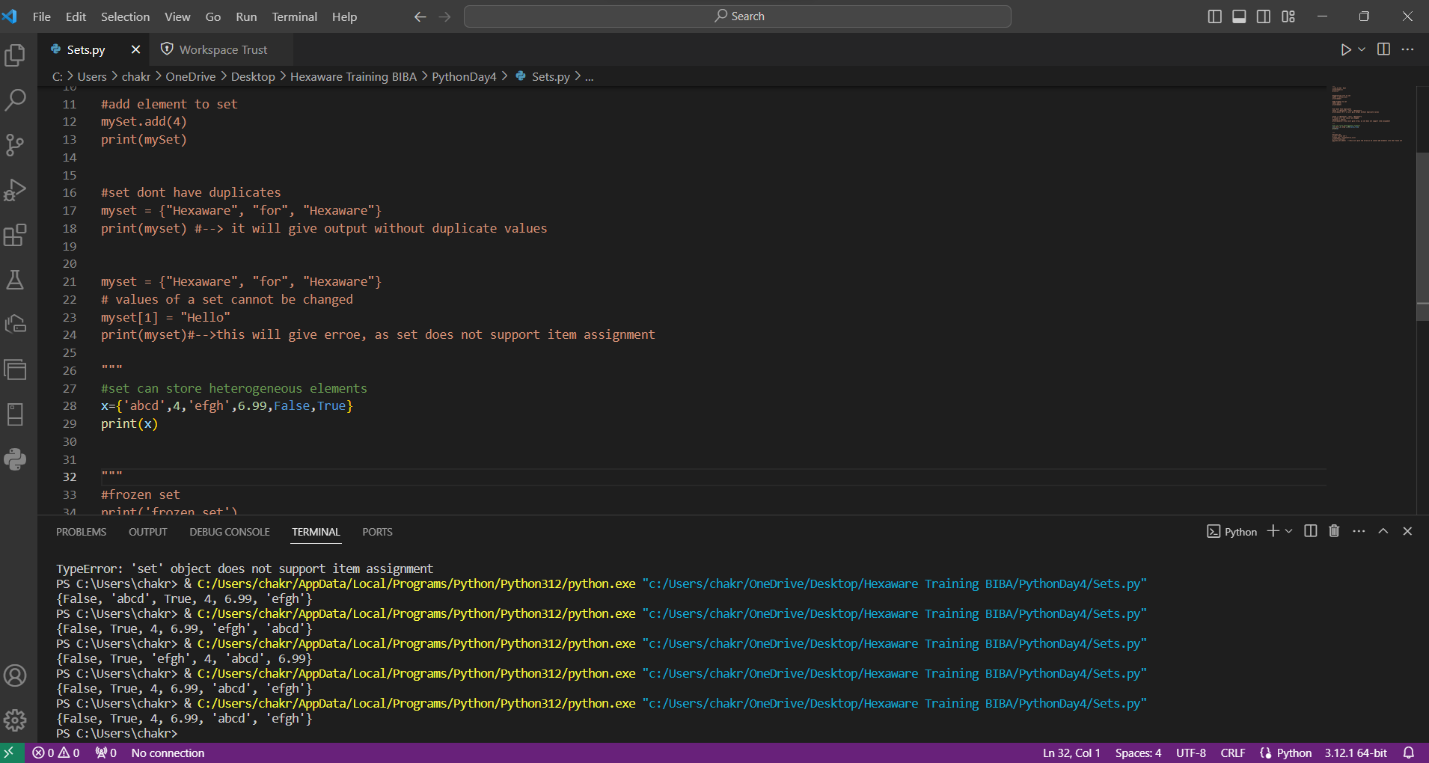

Frozen set : set that cant be updated

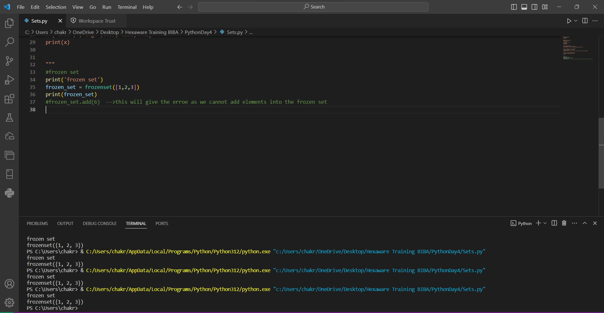

Add in Iterators : elements can be used using iterator

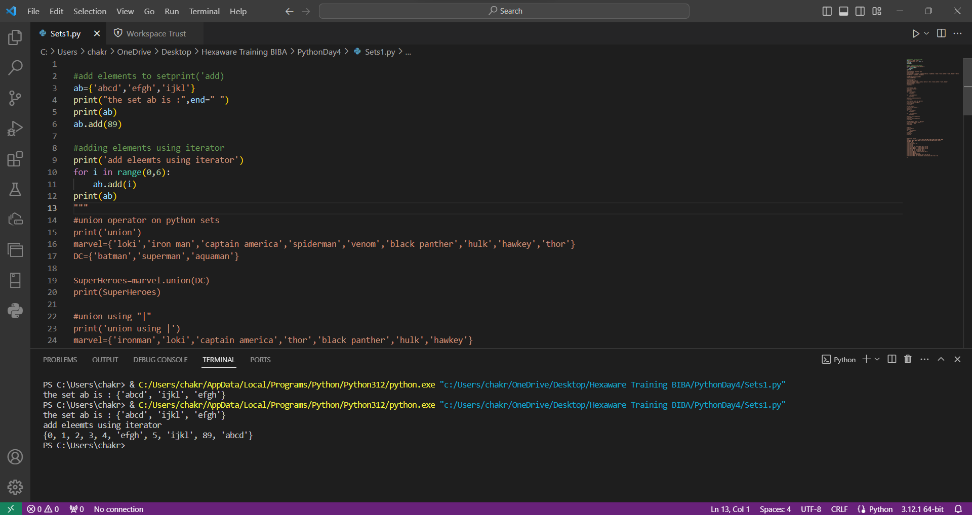

Union : Two sets can be combined using union() or “|”

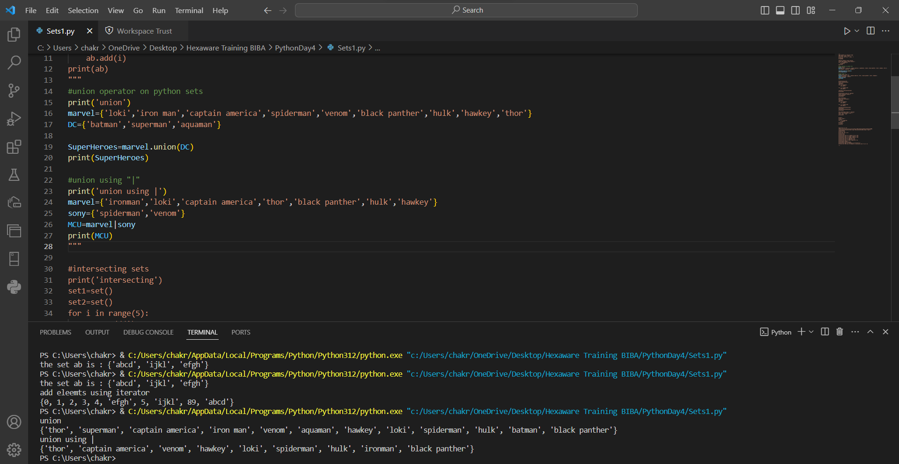

Intersection: common elements can be found using intersection() or “&”

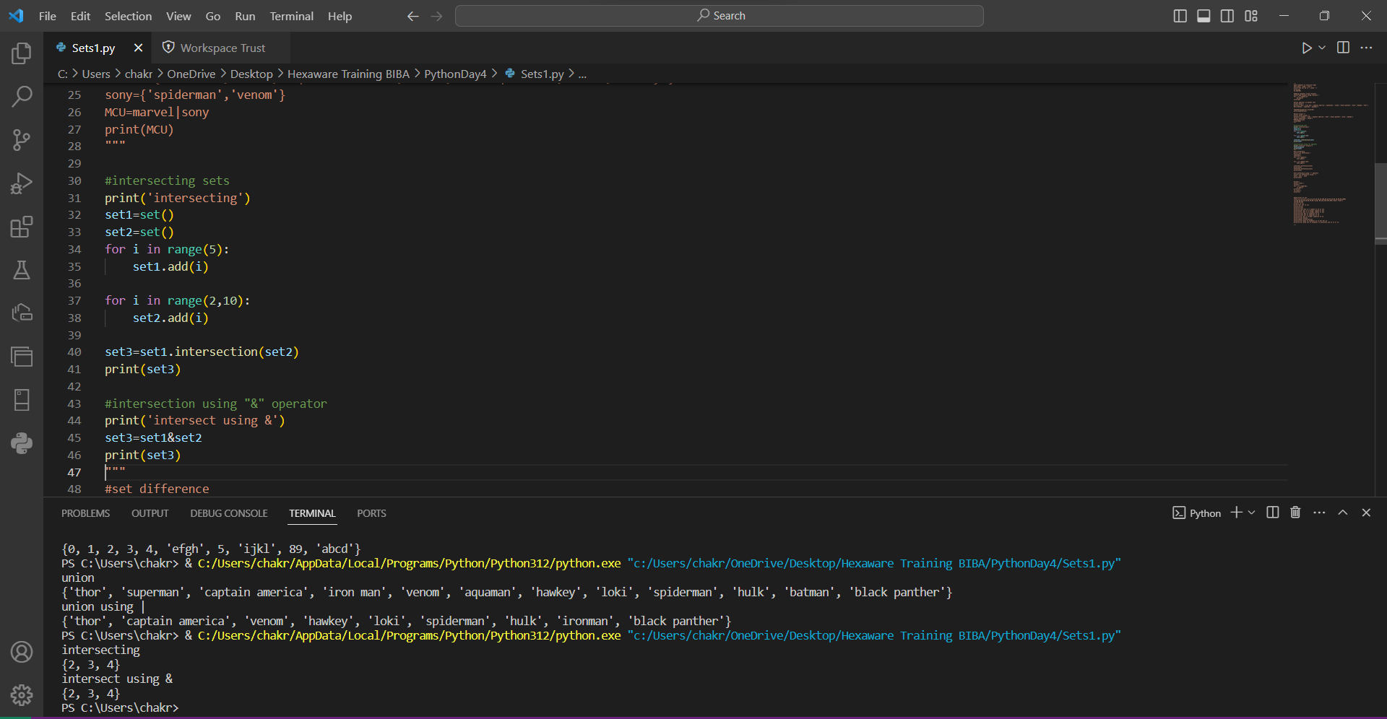

Set_difference: The difference between the sets will be the output

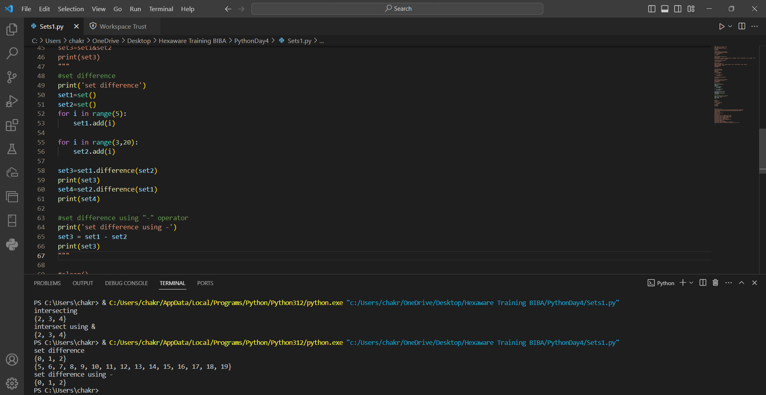

Clear : It empties the set

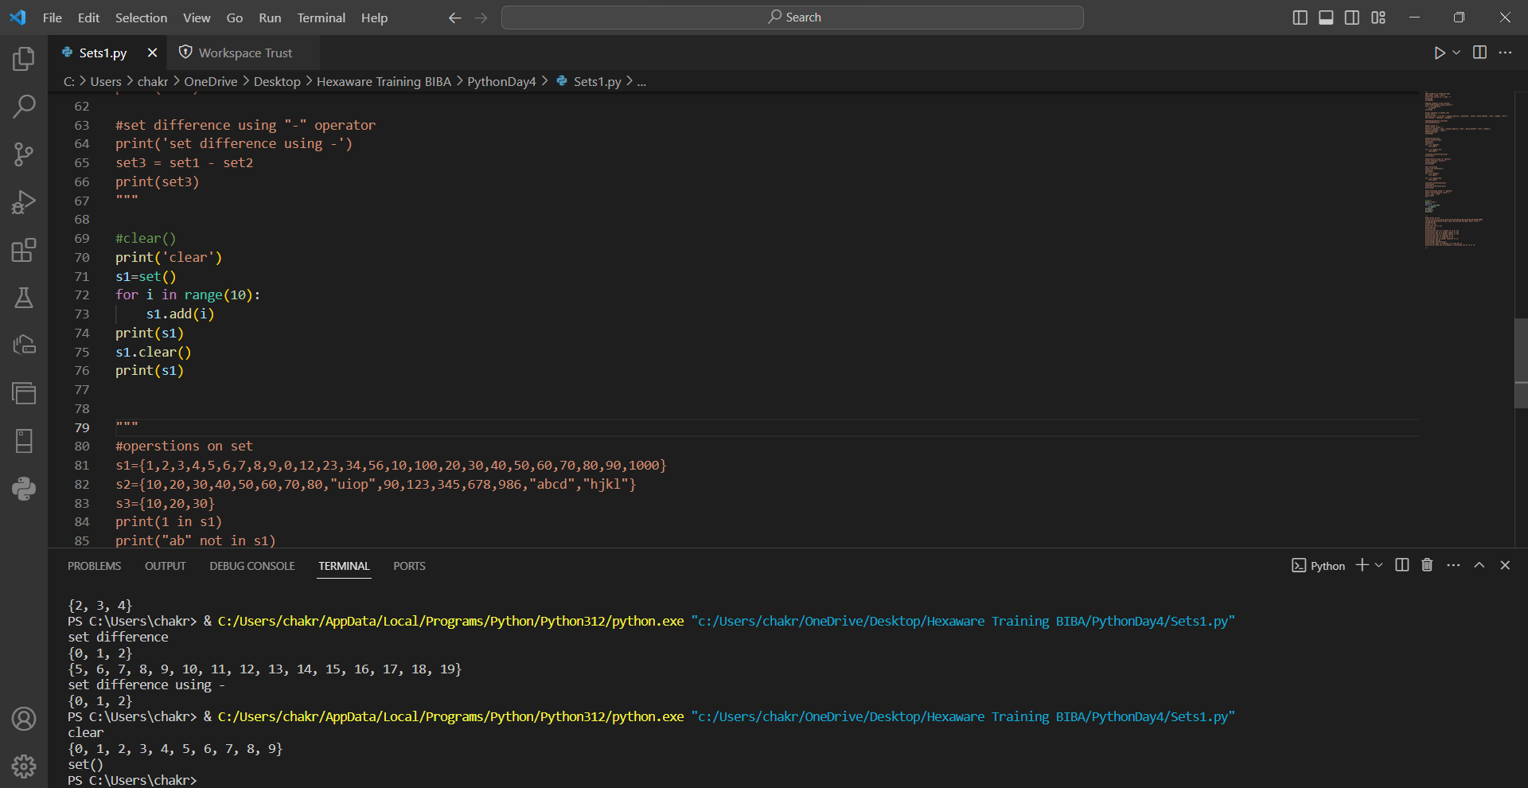

Operations on set

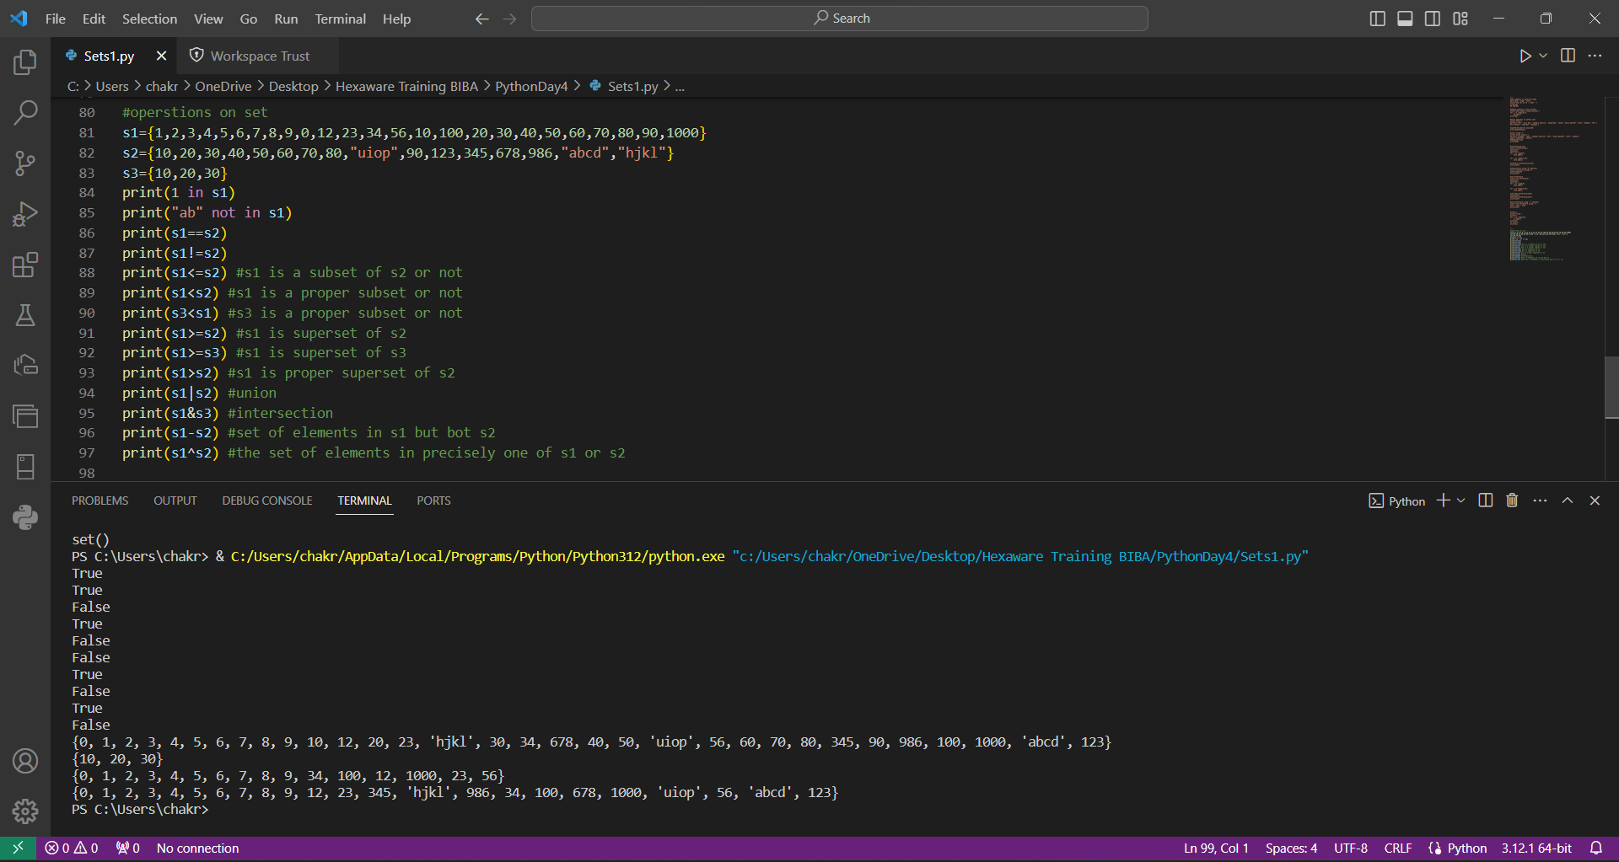

Discard : Discard will remove the element at a particular index

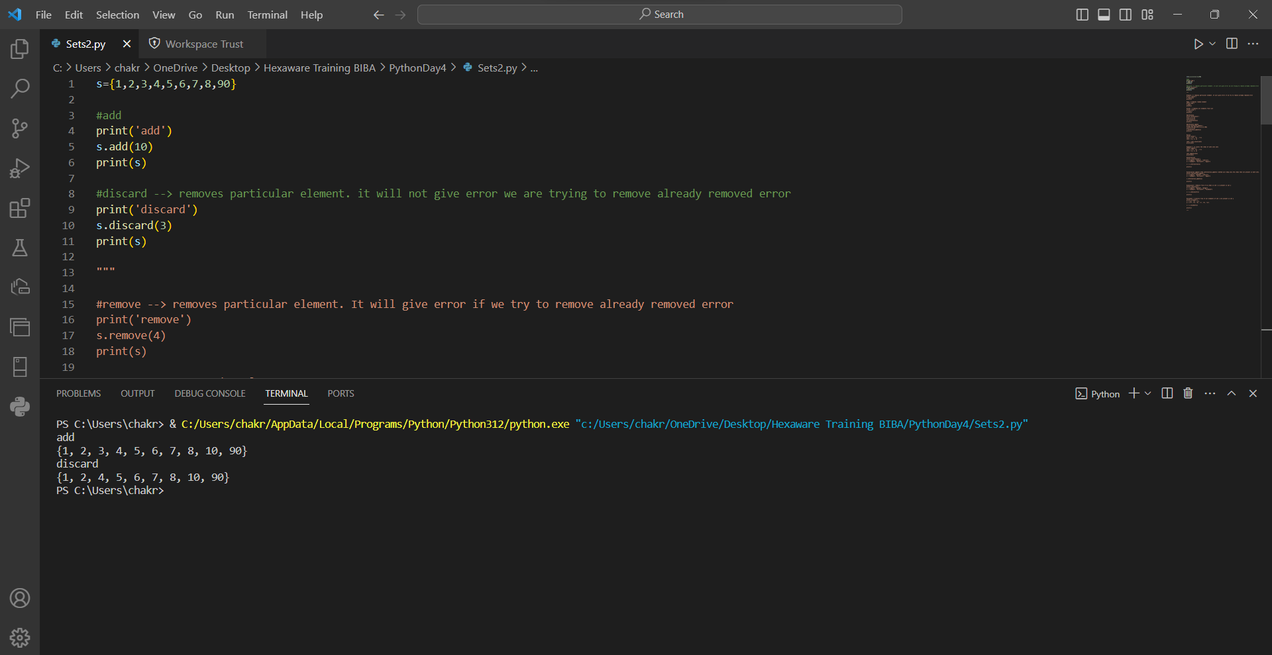

Remove, pop, clear : remove() will remove element from particular index. pop() will remove the anyone element that will be at last index. clear() deletes all the elements from the set

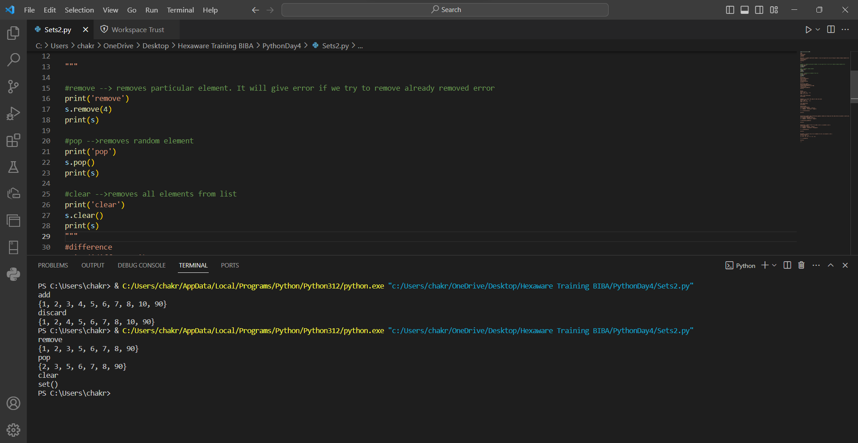

difference_update(): It gives difference between the sets and updates the same set

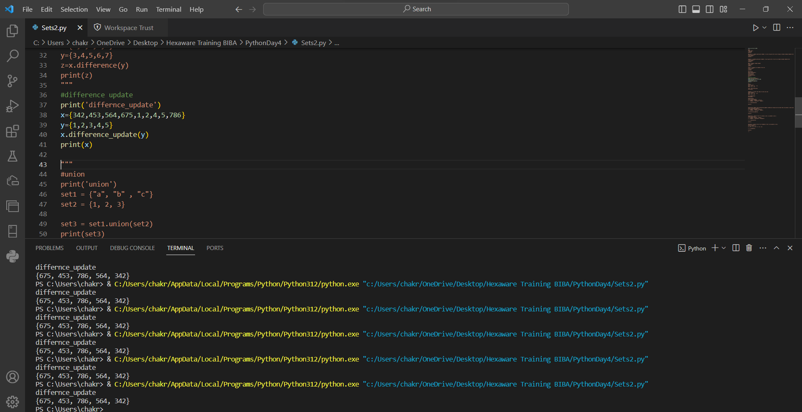

update() : It will add the new elements to the set

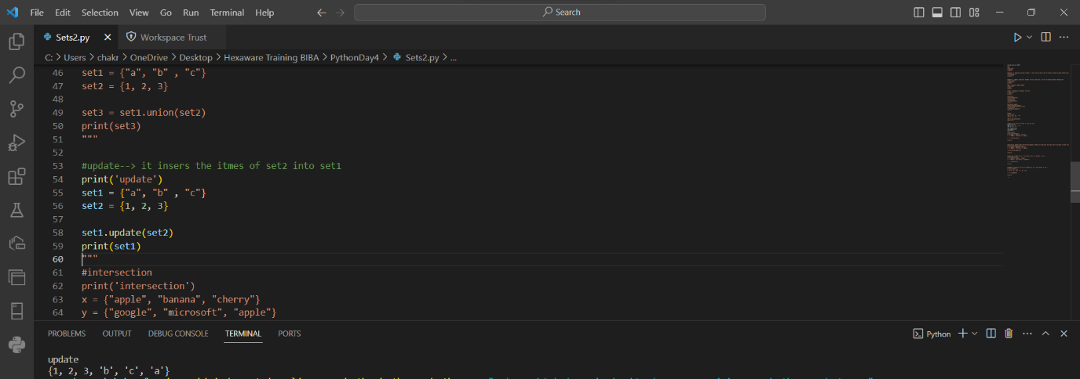

Intersection_update : We get the common elements and updates the one of the set that we want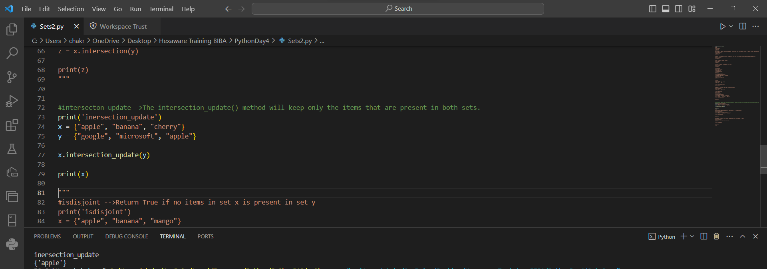

Isdisjoint() : Checks if the two sets have no common elements

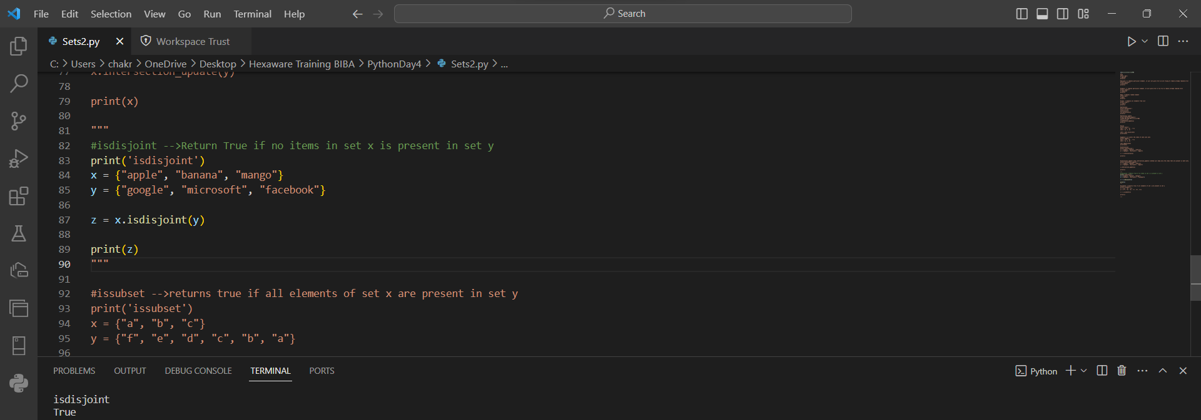

Issubset() : checks if one set is a subset of another set

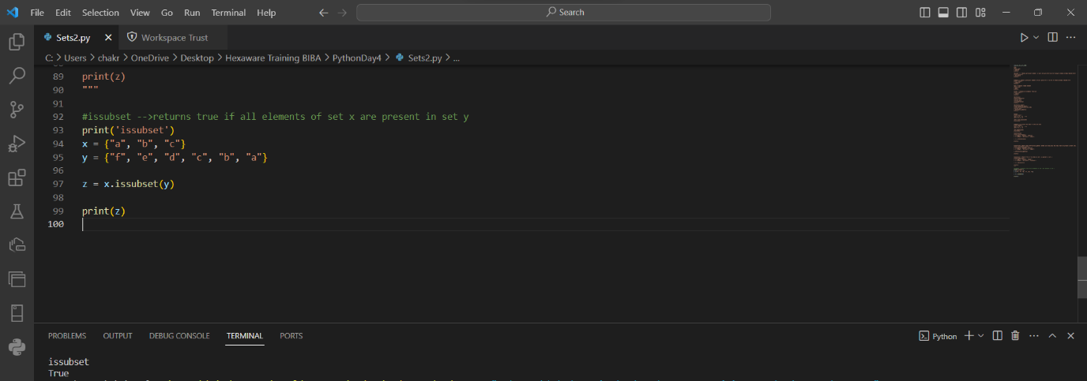

Adding tuple and list to a set

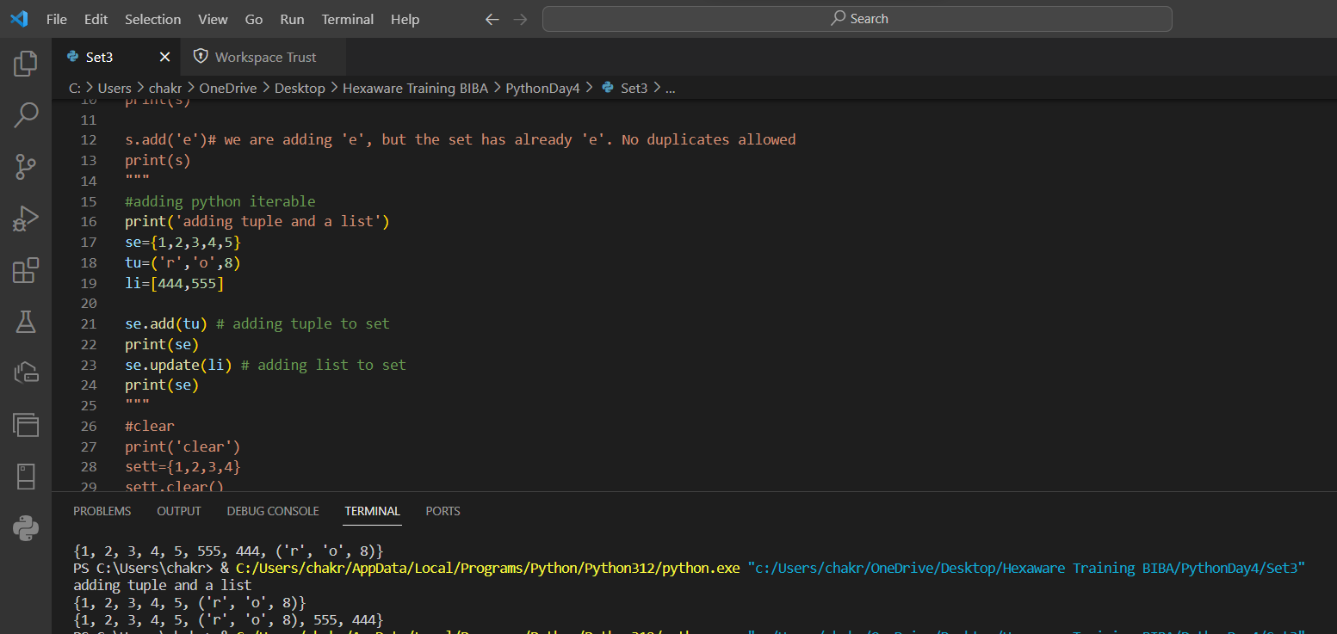

Copy : One set will be copied to another set

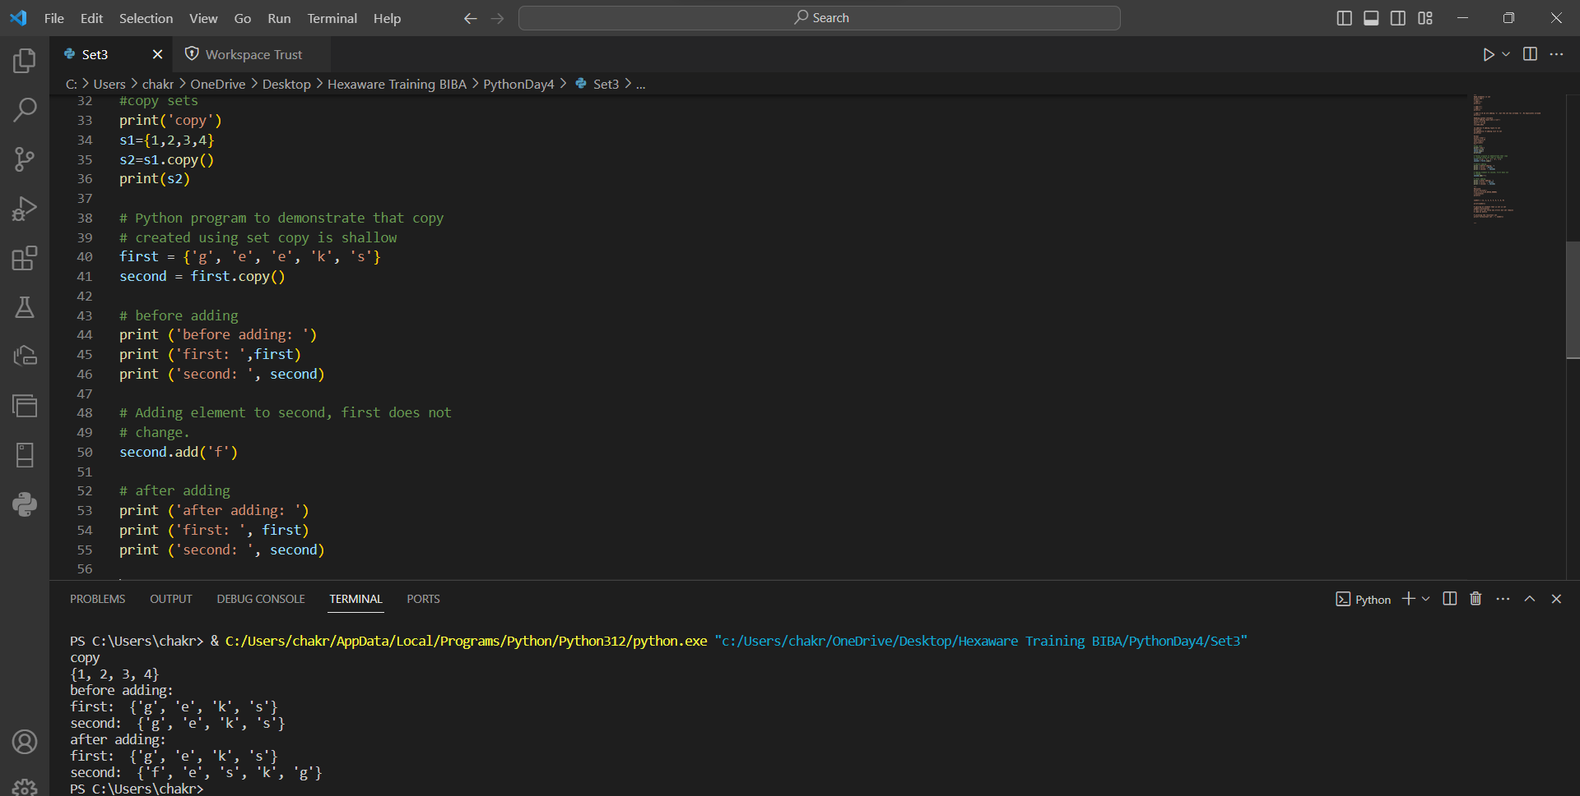

Functions

Function is a block of code that can be reusable

Syntax:

def function_name(arguments):

//statement

Function_name(parameters) #function call

Addition of two numbers

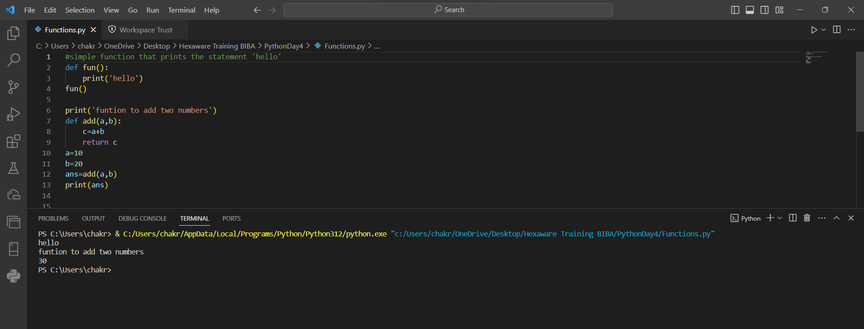

Even or Odd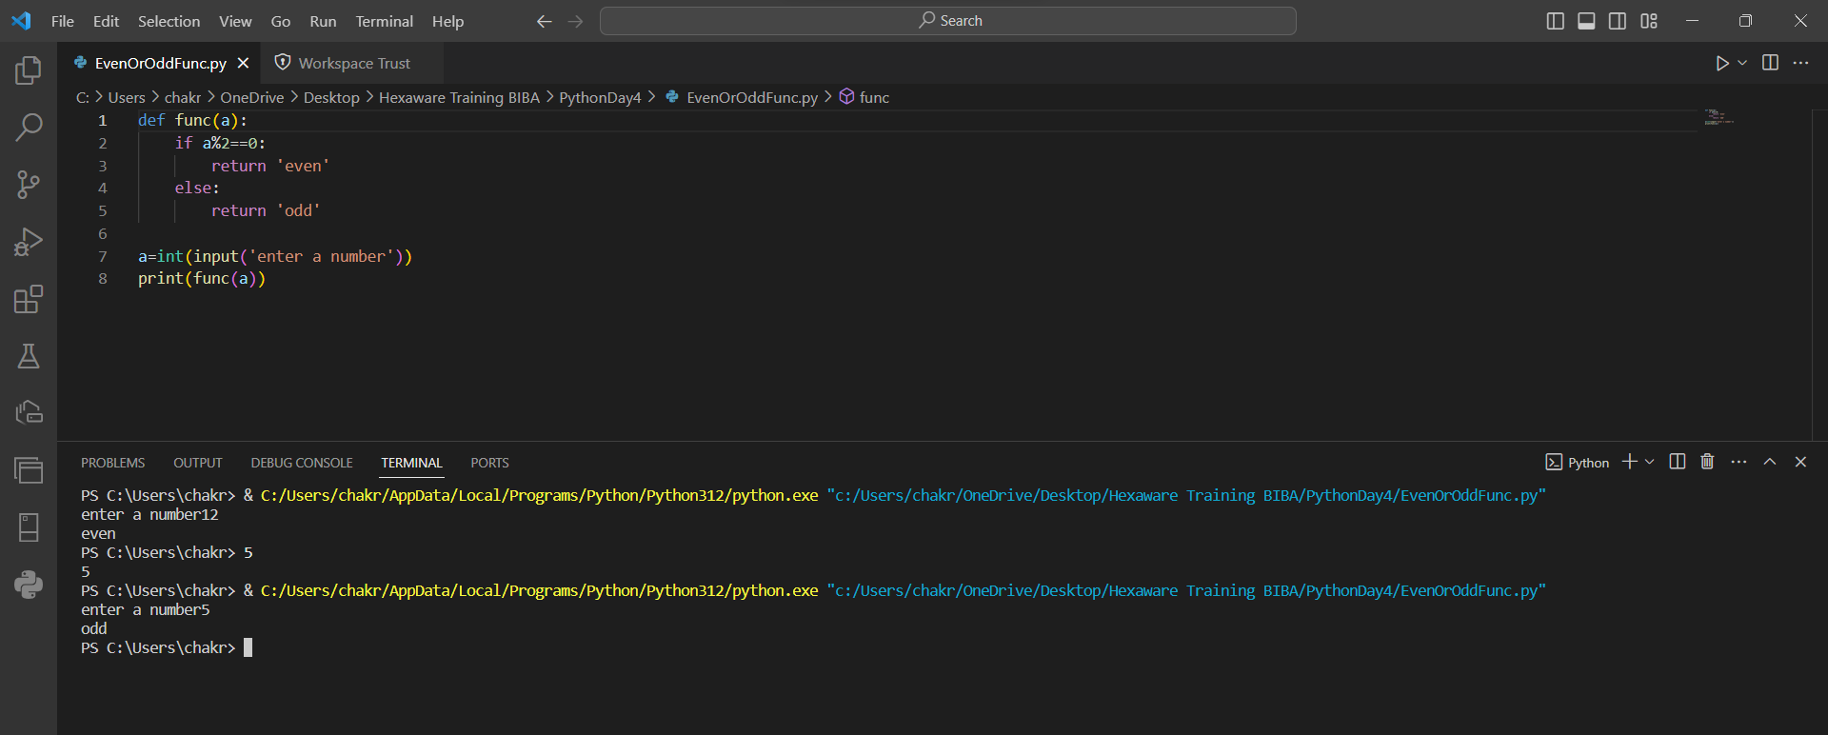

Default_arguments

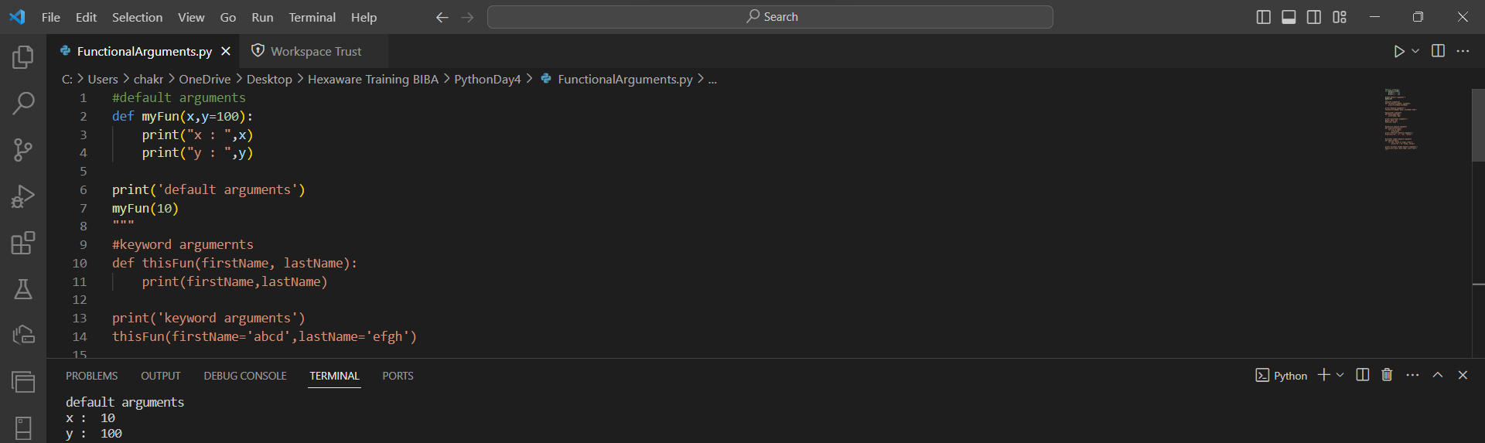

Keyword arguments

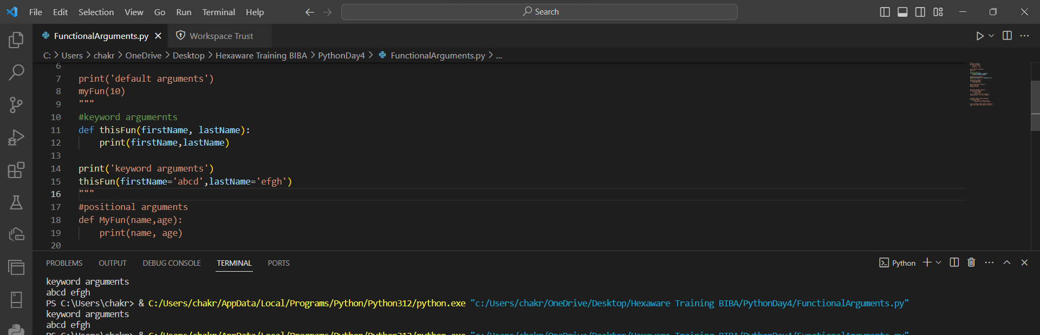

Positional arguments

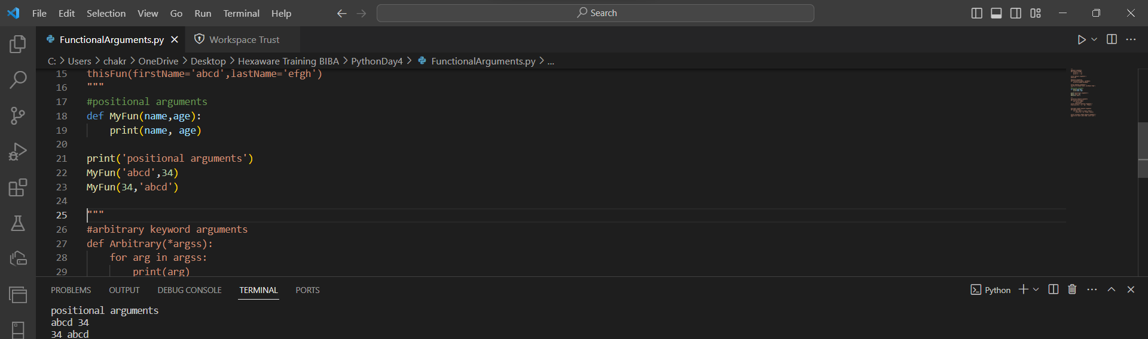

Arbitrary arguments

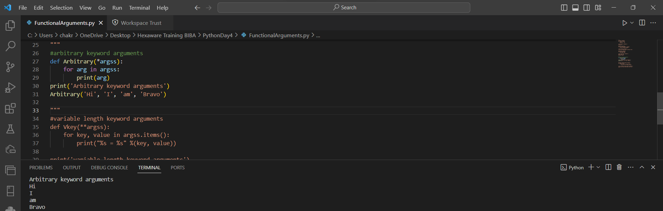

Variable arbitrary constants

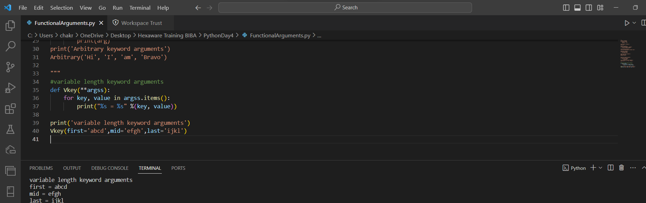

Prime number program

